RGB LED Interfacing to Arduino:

Introduction:
The RGB led aka the tricolor led is a led that can help generate a multitude of colors by mixing red, blue & green colors. Its more like 3 leds (red, green & blue) put together into a single led.It has 4 pins with 1 of the pins being a common cathode and the other 3 pins acting as anodes for the 3 different colours. by varying the intensity of each of the 3 colours individually, we can generate various colours. This led is the same as 1 pixel of a LED TV!.
Requirment:
- RGB LED
- Current Limiting Resistor
- Arduino Board
- Breadboard

Hardware configuration:
RGB LED as lock like this as given below.
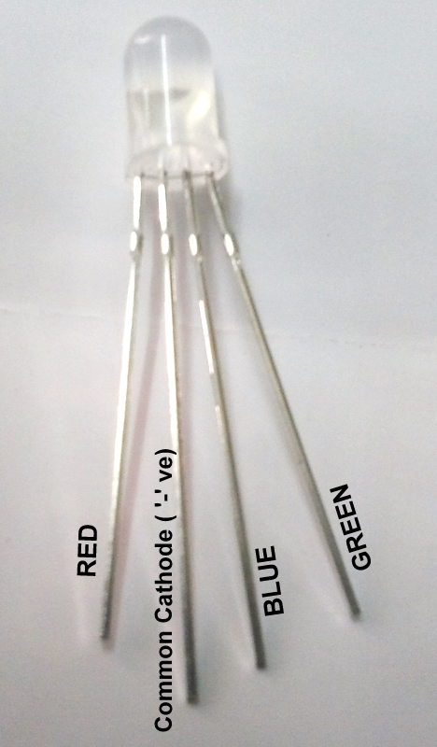
.

step1: place the RGB LED to the breadboard.
Step2:Place resistor between the common cathode and the '-'ve terminal of breadboard.
Step3:Connect RED to Pin 11, Blue to Pin 10 & Green to Pin 9 on the Arduino (these are PWM pins. And aslo proper ground pin of Arduino connected to the breadboard -ve terminal.

Programing:(source code)

Programming to control the RGB LED:

/*
RGB_Blink
Turns on each ofthe color spectrums for 4 seconds,repeatedly.
*/

void setup() {
// initialize the digital pins as an output.
pinMode(11, OUTPUT);
pinMode(10, OUTPUT);
pinMode(9, OUTPUT);
}

void loop() {
digitalWrite(9,LOW);
digitalWrite(11, HIGH);
delay(4000);
digitalWrite(11, LOW);
digitalWrite(10, HIGH);
delay(4000);
digitalWrite(10, LOW);
digitalWrite(9, HIGH);
delay(4000);
}
Installation:
The source code copy to the skeches of arduino and compile (there is verify option) as shown given below.
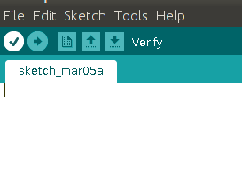

And then uploding the source code.(there is uploding option) to the Arduino board.(software) as shown given below.
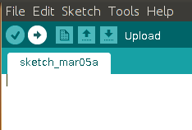

Troubleshooting:
FAQ:
Maintainers:
Duryodhan Aldar (durva.ges@gmail.com)

References: http://quickstartkitforarduino.blogspot.in/

